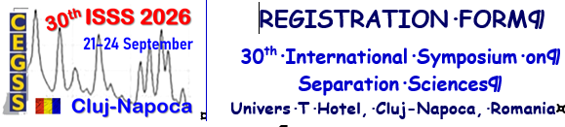

Title / Position: …………………………………………...……………………...
Name: …………………………………………………………………………....
SURNAME: ……………………………………….……………………………....
Full Affiliation: ………………………...……………….……………………...…
………………………...……………….…………………………………….…...
Full Address: ………………………………………………………………….….
………………………………………………………………………………...….
Participation (mark below with X): ………………………………………….…...
Topic (no. / title): …………………………………………………….………..
Oral presentation: (10 min) ….……; (15 min) ……….; (20 min) ….……….
Flash poster presentation*: ….……...; e-Poster presentation** ….………...
One day participation: ….……....…...; Without presentation: ….…….......…
Email Address: …………………………………………………………………...
Phone (optional): ………………………………………………………………...
Accompanying-person(s): ……………………………………………………….
Preferred Menu (mark with X): Normal ……; Vegetarian ……; Other ………...
________________________________
*The flash poster presentation consists of a short communication of five to ten slides (Title, Authors, Affiliation(s), Aim, Experimental, Results, Conclusions) for five minutes, followed by two minutes of discussion (PhD Students).
**The e-poster presentation (A0 format portrait) consists of a short three-minute communication.

